Kehinde Charles-Pedro

02/05/2023

DQ

1. Do you think Socrates was overreacting to the downfall of writing and books due to significant changes in how books were created? Would you agree with Greece's bold overlook of technology-changing storytelling, debating, and writing? (page, 55)
2. “A book is never simply a remarkable object. Like every other technology, it is invariably the product of human agency in complex and highly volatile contexts” Why are books complex too study in compare to sitting in front of laptop? ( page, 48)
3. Is a book more than just an ‘object’? And is our form of reading lackluster compared to ancient monks' reading style? (pages, 18 and 53)
4. “After Muhammad’s death, Caliph Uthman compiled an authoritative version, and the Qur’an took shape as a parchment codex”( page, 31) How does the importance of death change a book's physical form? What significant meaning does the change have over a book's evolution? Do you believe a book should change due to its religion or time or respect for its author?
5. The inventions of the alphabet by the Greeks and hieroglyphics proved to be easier when creating a book. But if you were an author and were given a task to write your text using the Greek or Egyptian alphabet would you be able to do so? Would you prefer 21-st century writing material or papyrus?

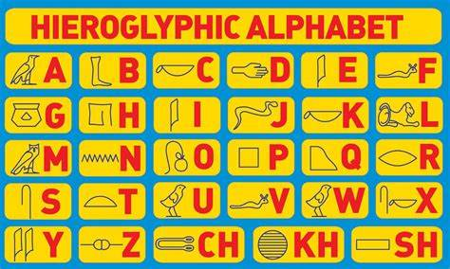

1. How does the papyrus resemble a digital reading device? (page, 16)

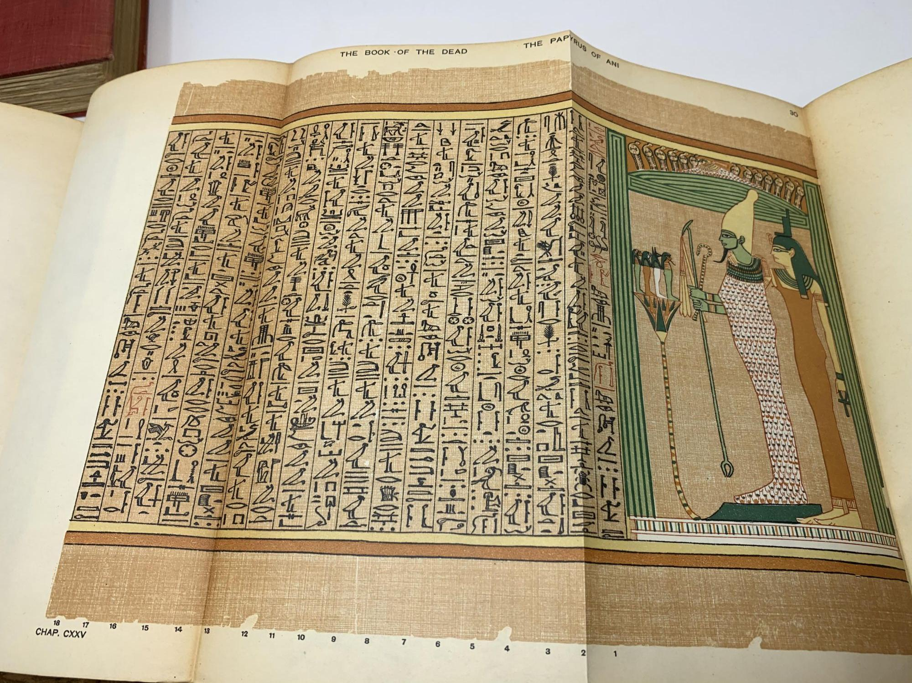

Youtube links

<https://www.youtube.com/watch?v=_YqYtdPUis4>

<https://www.youtube.com/watch?v=JJtxBkTJJf8>